The following article describes how a decision tree is structured and how it works.
Table of contents:
1. Basics
2. Dataset, Features, Labels
3. Determination of Root Node
4. Further Calculation
5. Dealing with numerical values
6. Dealing with ordinal data
7. Dealing with nominal data
8. Code Example
1. Basics:
The decision tree is a tree-shaped diagram used to establish a course of action. Each branch of the tree represents a possible decision, event or reaction. The decision tree can be used for both regression and classification problems.
Terminology:
Gini-Impurity:
Given a data table that contains atributes and class of the attributes, we canmeasure homogenity/heterogenety of the table based on the classes. A table is pure/homogenous if it contains only a single class. If a data table contains several classes, then we say that the table is impure or heterogenous. There are several indicies to measure the degree of impurity. The gini-impurity is one of them and is used to explain the procedure of a decision tree.
Leaf Node:
Contains the result
Decision Node:
Has two or more branches
Root Node:
The topmost node is the root node

2. Dataset, Features, Labels
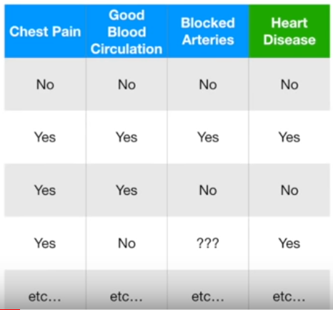
the example for the prediction of heart disease now illustrates the operation of a decision tree. The dataset contains 303 patients (= samples)

The features used here are:
Feature 1: Chest Pain (0, 1)
Feature 2: Good Blood Circulation (0, 1)
Feature 3: Blocked Arteries (0, 1)
These features are intended to predict whether a patient is suffering from heart disease or not:
Label = Heart Disease (0, 1)
3. Determination Root Node
For the decision tree, it must first be determined which of the 3 features should be used as root node. It checks how well each feature alone predicts the Heart Disease label. This is done by calculating the "impurity", which is calculated using the Gini index.
Example of Chest Pain:
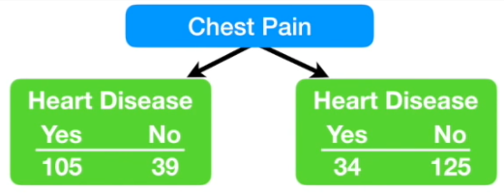
For both leaf nodes, the Gini index is calculated. This results from the formula:

is the ratio of class k instances among the training instances in the i^{th} node.
Left Leaf Node:
1 – (proba of „yes“) ² – (proba of „no“)² = 1 – ()² - ()² = 0.395
Right Leaf Node:
1 – (probay of „yes“) ² - (proba of „no“)² = 1 – ()² - ()² = 0.336
Based on both Gini values, the Gini index of "Chest Pain" is calculated. However, since the left and right leaf nodes contain a different number of patients (left: 144, right: 159), the average is now formed from the two Gini values:
() ⋅ 0.395 + () ⋅ 0.336 = 0.364 (Total impurity von „Chest Pain“)
Now total impurity of "Good Blood Circulation" and of "Blocked Arteries" have to be calculated in the same way. Finally, all Gini values are compared and the lowest is determined as the root node for the decision tree.
Gini-Index of „Chest Pain“:
= 0.364

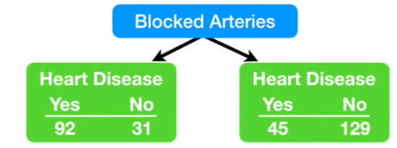
Gini-Index of “Blocked Arteries”:
= 0.381

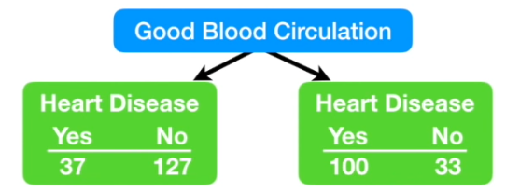
Gini-Index of „Good Blood Circulation“:
= 0.36 ( = Root Node)

"Good Blood Circulation" best separates patients with Heart Disease and without Heart Disease and thus is now used to be the Root Node.
The decision tree now looks like this:
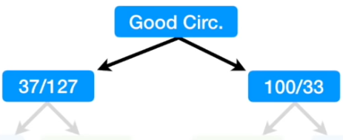

4. Further Calculation
After all patients were subdivided after "Good Blood Circulation" was applied, new "impure" leaf nodes appeared again. It is now being investigated to what extent "Chest Pain" and "Blocked Arteries" separate the patients of a leaf node (left 164) after Heart Disease. Now the Gini index is recalculated for both features. That feature with the lower index will be included as a new node in the decision tree.
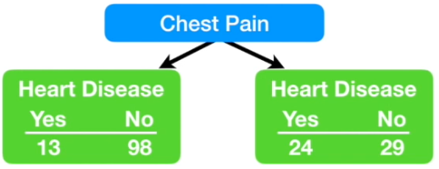
Gini-Index of „Chest Pain“:
= 0.3

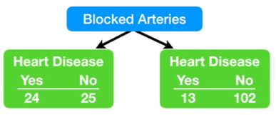
Gini-Index of „Blocked Arteries“:
= 0.29

"Blocked Arteries" has the lower Gini index and is therefore included as a new decision node in the decision tree. The decision tree now looks like this:
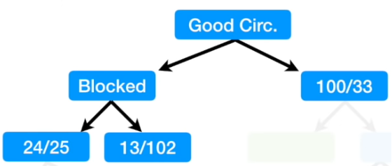

Now only "Chest Pain" is left. The left node now checks how well "Chest Pain" separates the 49 patients. This happens again with the determination of the Gini index.
This can be saved in this case, however, because at first glance it is clear that "Chest Pain" separates the remaining 49 patients very well for Heart Disease / No Heart Disease.
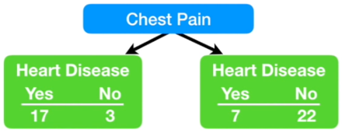
Gini-Index of „Chest Pain“:
= 0.321

This results in the following decision tree with 2 final leaf nodes on the left side.
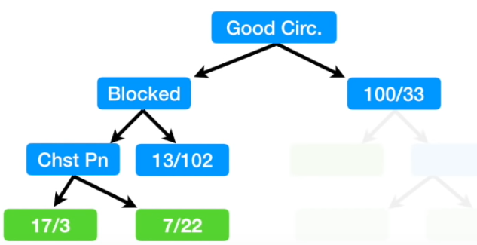

For the circled 115 patients it is now determined whether it makes sense to separate them for "Chest Pain". For this, the Gini index is again calculated from the following data:

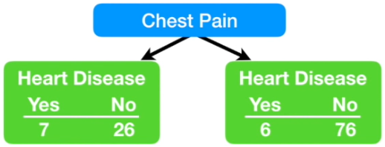
Gini-Index of „Chest Pain“:
= 0.29

However, since the Gini index of the encircled node is at 0.2, it is now omitted to use "Chest Pain" for further separation. The circled node becomes a leaf node. The result is the following decision tree, where the complete left-hand side is finally calculated.
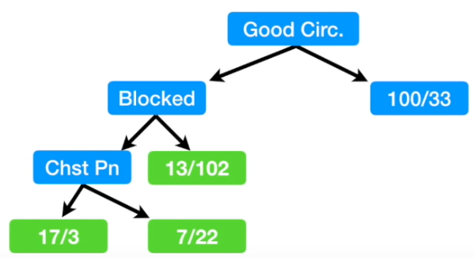

The calculation of the right sides is now analogous to the left side. In general, the following points should be considered:
1. Calculation of Gini values
2. If the node itself has the lowest Gini index, no further separation is necessary and the node becomes a leaf node.
3. If the separation of the data leads to an improvement, the feature with the lowest Gini index is selected.
However, it should be considered that all previous features of binary form (yes / no) were. It can also happen that a feature is structured in a different way. Possible features could be: numeric values, ordinal data and nominal data.

5. Dealing with numerical values
Now we will describe how the data can be divided based on "Weight":
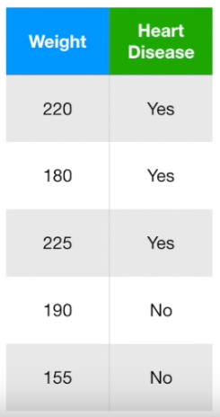

- step: ascending sorting by weight
- step: Calculation of the average of the neighboring patients
- step: Calculation of the Gini values of all
averages
- step: Choose the average value with the lowest Gini index for further separation

6. Dealing with ordinal data

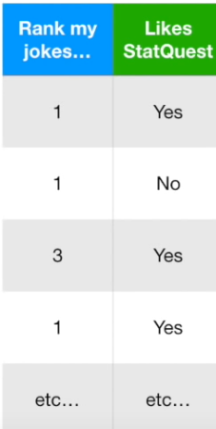
      - determine Gini index for "Rank my jokes" <= 1,
<= 2, etc.
      - The value with the lowest Gini index is taken for further separation

7. Dealing with nominal data
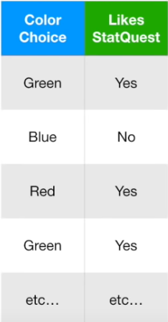
- Calculation of the Gini index for each individual expression and every possible combination
- The value with the lowest Gini index is taken for further subdivision

8. Code Example

# Creates a decesion tree model with a maximum node depth of 5 and with at least 2 numbers of samples per leaf:
MODEL = DecisionTreeClassifier(criterion="gini",
max_depth=5,
min_samples_leaf=2)

# Exports the tree as a PNG-file:
TREE = export_graphviz(MODEL, None,
feature_names=["monthlySport", "monthlyHealthyFood"],
class_names=["no desase", "desease"],
rounded=True,
filled=True)

SRC = graphviz.Source(TREE, format="png")
SRC.render("./datei", view=True)

